**- Fix/ Implement functionality adding contact automatically and also simultaneously on both sides with external link**

**\* AAAA user input the BBBB’s link and click continue(at this time send connect request and wait request received and the other’s send request)**

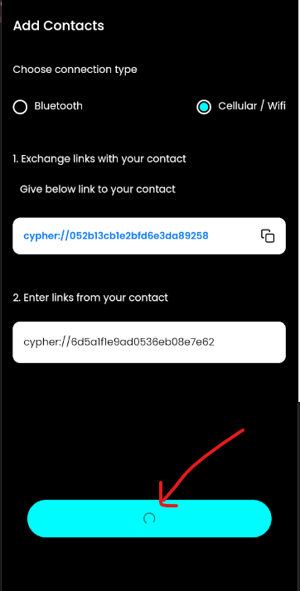

**\* BBBB input the AAAA’s link and click continue(at this time send connect request to AAAA and if receive AAAA’s request received same time, then connect each other)**

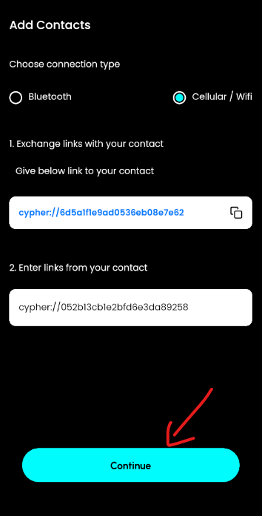

**\* if both aceepted request successfully same time, status changed from ‘pending’ to ‘accepted’, then add user contact in both side.**

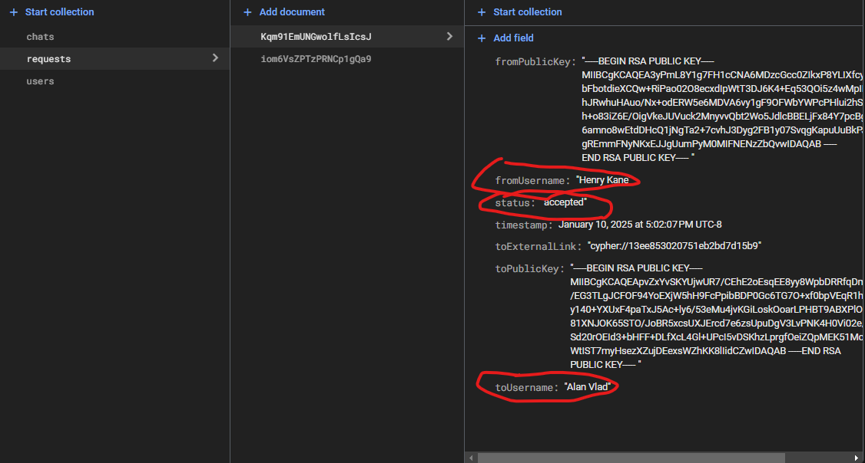 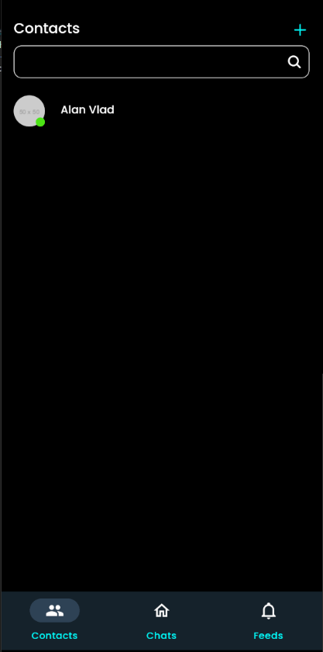

**- Fix Navigator style**

**- Implement functionality real-time chat between users**

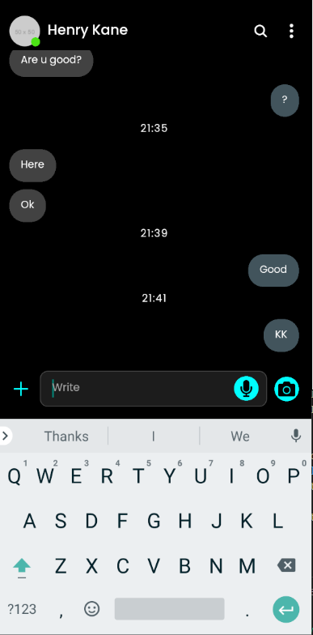

**- Add chats collection on firebase firestore for real-time chat**

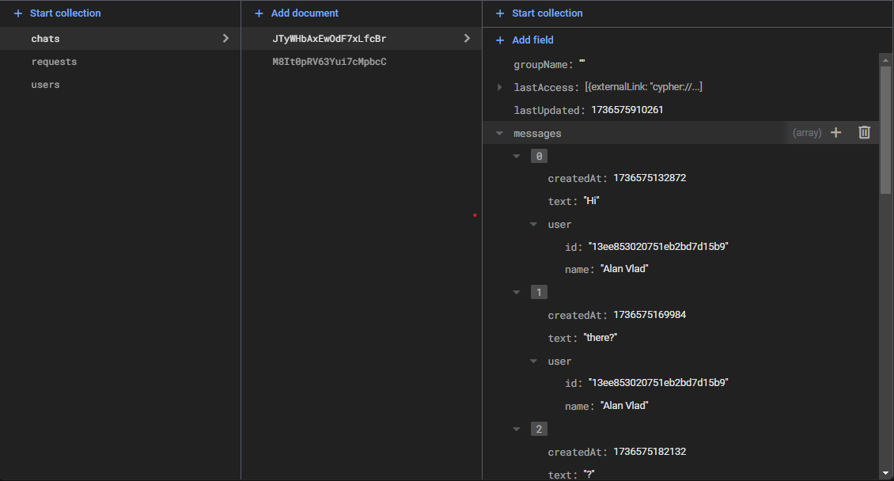

**- fix Main Chats UI/UX with pixel perfect design**

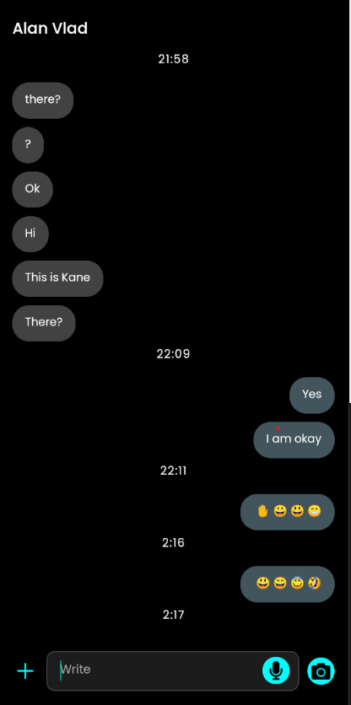

**- Implement emoji modal functionality.**

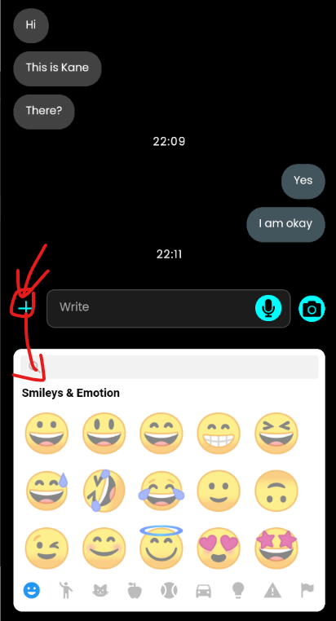 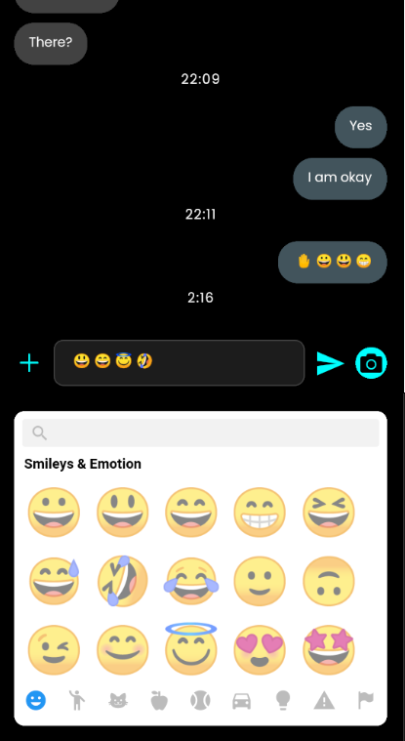 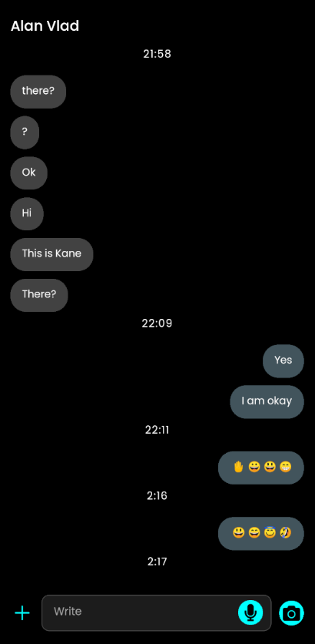

**- Implement unread message functionality if user outside of chatroom, and also show latest message on the chats screen.**

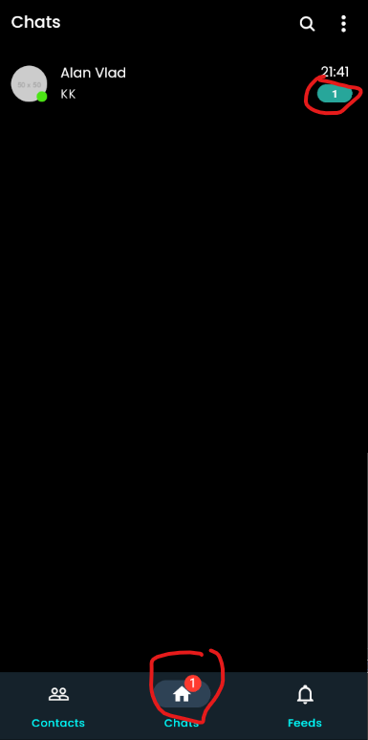 

**- Implement functionality add contacts to the group.**

**\* click contact panel long, show select contact and also make group**

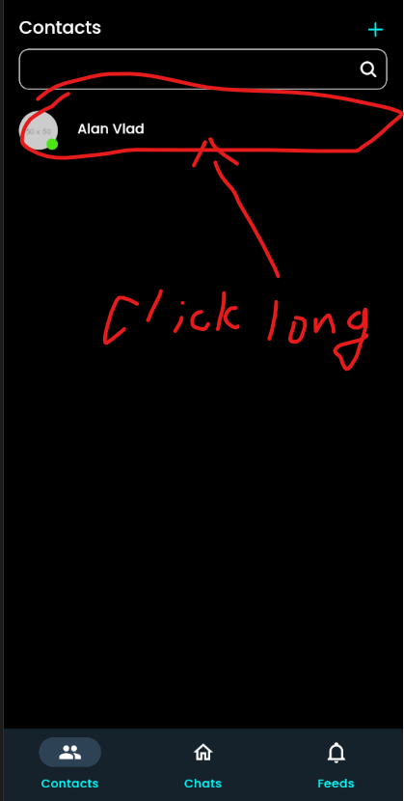 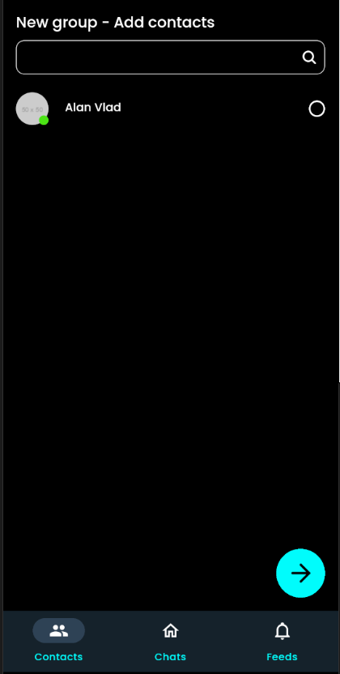

**\* select users and click arrow-right button go to group name screen**

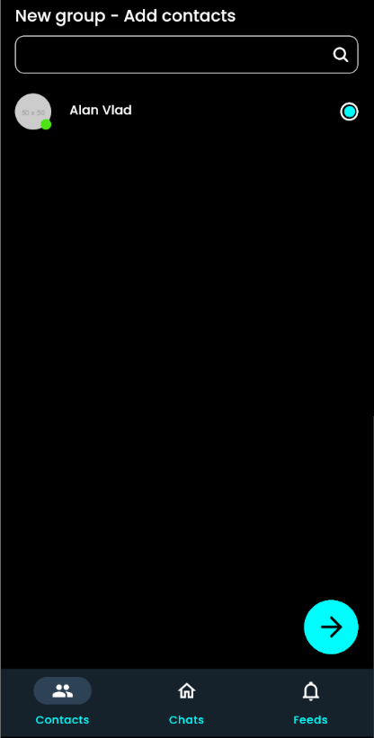 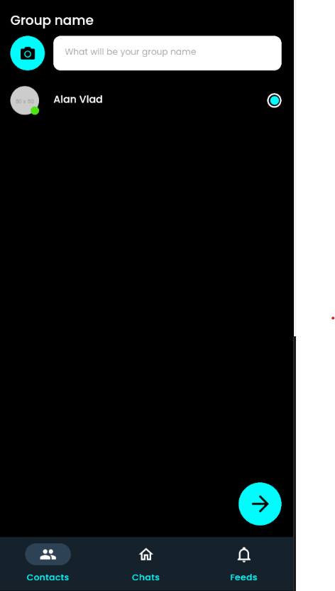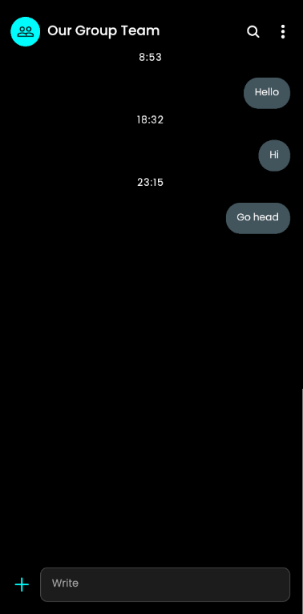

* user didn’t’ input group name, show alert, after this, add group to the chats screen

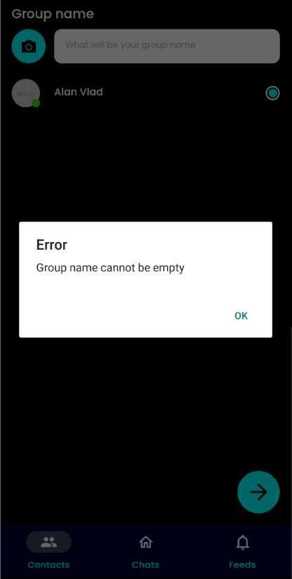 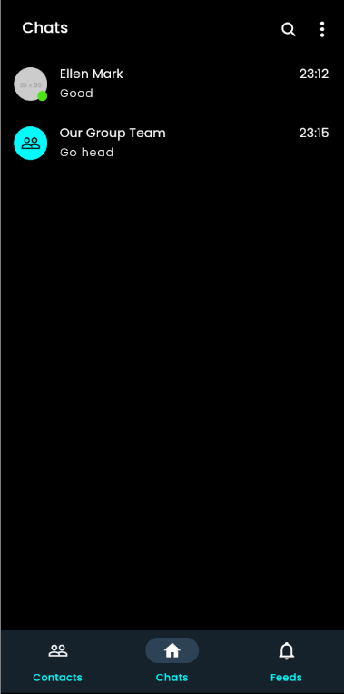

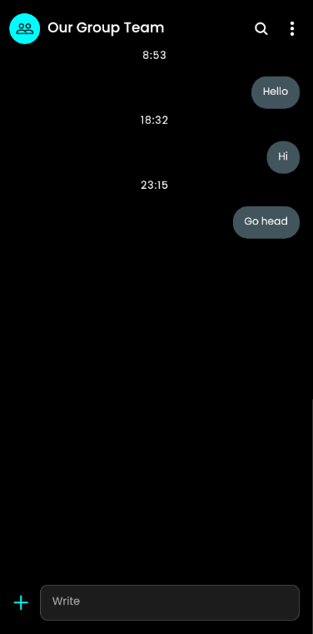

**- Implement functionality group chat input box**

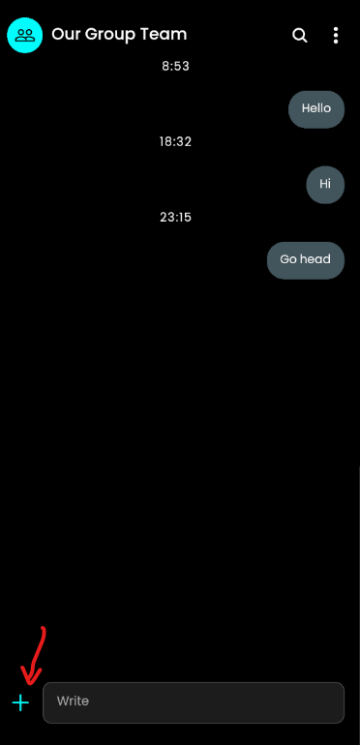 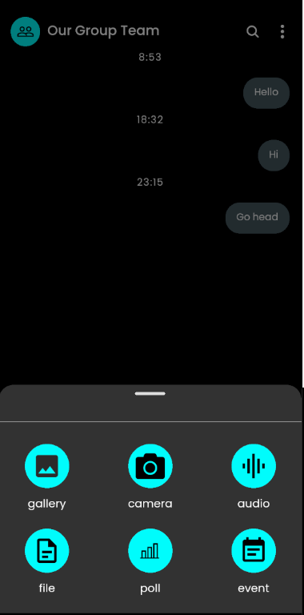

**- Implement functionality show group profile**

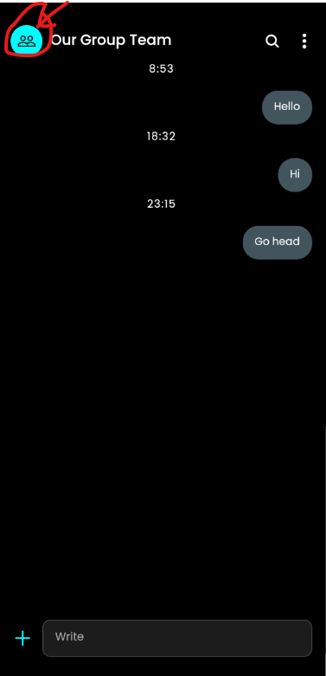 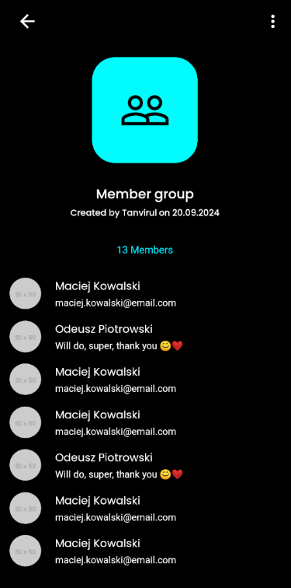

*when user click group icon go to see profile page

**- Implement functionality edit group profile**

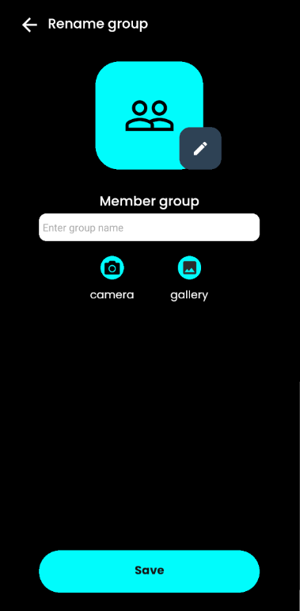

**- Implement Poll and Event UI/UX and basic functionality**

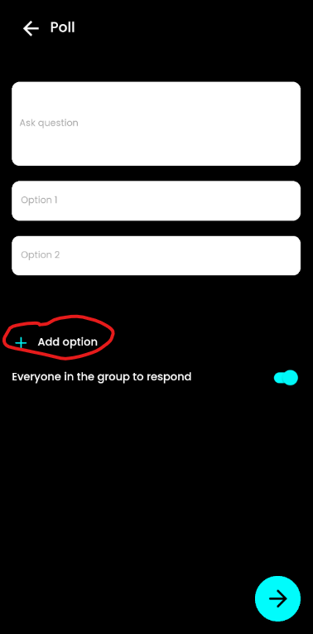 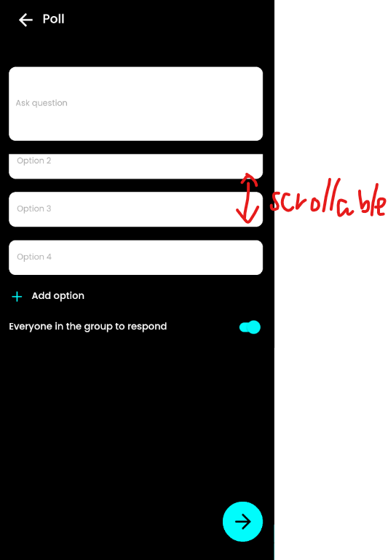

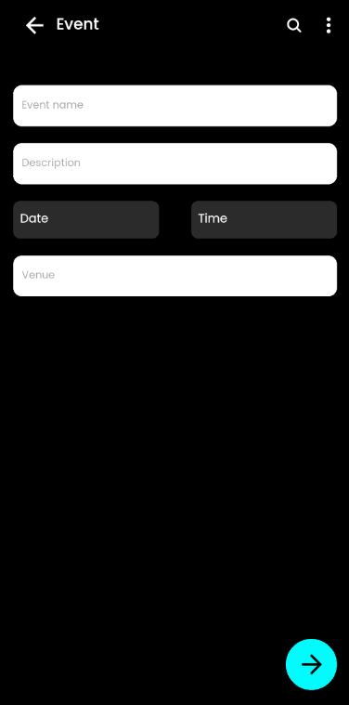

**- Implement Secure Message encrypt/decrypt**

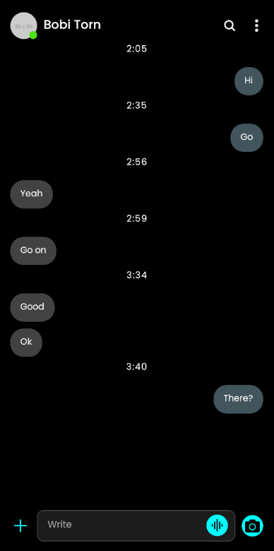 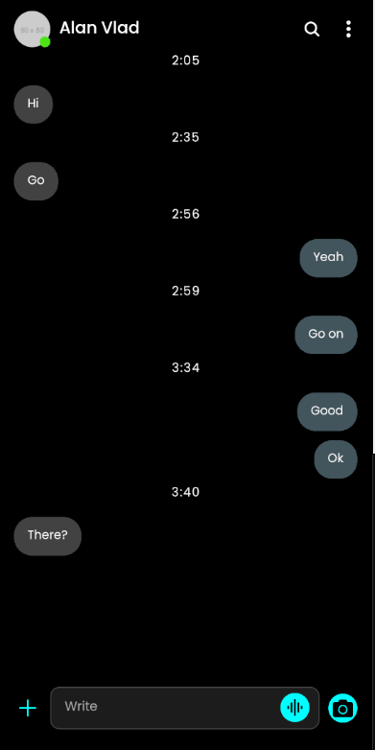

**When user input and send message,**

* generate private, public key/pair by using blockchain cryptographic

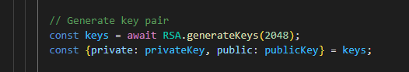

* encrypt first by using with sender and recipient’s public key,

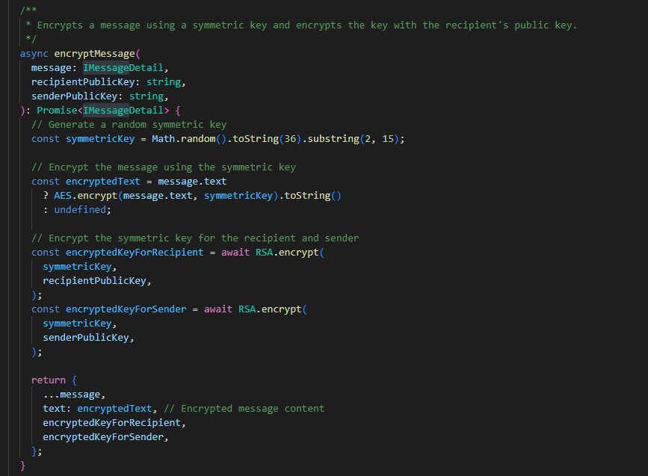

* after encrypt, store local storage

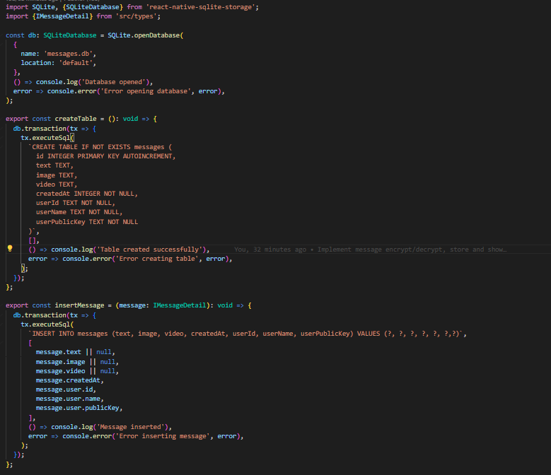

* when load message, decrypt sender or recipient’s private key, and show message

(only messages can be shown by decrypting with their private key stored on the user’s phone)

